Template for Extended Abstract up to 2 pages for the ERMR 2027

First A. Author¹, Second B. Author2 and Third C. Author3

^{1, 2} Authors’ Department, Institute, Organisation, Country
(E-mail: firstauthorsname@aaaa.bbb, secondauthorsname@aaaa.bbb)
³ Author’s Department, Institute, Organisation, Country
(E-mail: thirdauthorsname@aaaa.bbb)

Short abstract: Abstract should be written with a sans-serif (Arial, Segoe UI) 10 font size, single line spacing. The abstract should contain no more than 100 words.

Keywords: maximum, five, comma, separated, words.

1. INTRODUCTION
This document provides the official formatting guidelines and submission instructions for the 20th ERMR Conference Extended Abstracts. All submissions must be written in English and should not exceed 2 pages in total length, including the abstract, body text, figures, tables, and references.
The extended abstract should be submitted in either ‘.docx’ or ‘.pdf’ format. To maintain graphical consistency across the conference proceedings, authors may use the provided Microsoft Word template or the official ‘ermr2027.cls’ LaTeX class file. Note that, when using the latter option, all formatting is taken care of by the LaTeX engine. It should be formatted on A4 size paper with 1-inch margins on all sides. Presenting author’s name should be underlined. Please leave one blank line (10 point) after the title and another after the list of authors. The body text should be in 10 point Times New Roman, single line spacing and justified layout. Page numbers are to be provided at the bottom-center in Arabic numerals size 10 point. The extended abstract should generally contain the following sections:
- Introduction
- Objectives
- Material and Methodology
- Results and discussion
- Conclusion
- References
Section headings may be renamed or modified by the authors if required by the specific nature of the research work. Subsections are allowed. Each section headline should be in Times New Roman, 12 point, bold, and all caps, written left aligned. The extended abstract can contain figures, tables, and images.

2. OBJECTIVES
The objectives of presented paper must be clearly defined and highlighted.

3. MATERIAL AND METHODOLOGY
All materials, experimental setups, and mathematical methodologies utilized throughout the development of the study must be stated clearly. Subtitles should be employed to organize distinct subsections whenever necessary.

3.1. SUBTITLE
First-degree titles (2.) should be in Times New Roman, 11 point, bold, and all caps, written left aligned. Second-degree subtitles (3.1.1) should be written in the same format as first-degree titles.

4. RESULTS AND DISCUSSION

4.1. SUBTITLE
Supporting graphics, data tables, mathematical formulae and digital images may be included in the extended abstract. All tables, images, and figures must be centered horizontally on the page and numbered sequentially. The table caption must be placed at the top of the element, as demonstrated in Table 1. Figure captions must be placed directly beneath the image or graph, as demonstrated in Figure 1.

Table 1: Example Table
Column Heading | Column Heading | Column Heading
Row 1a | Row 1b | Row 1c
Row 2a | Row 2b | Row 2c
Row 3a | Row 3b | Row 3c
Row 4a | Row 4b | Row 4c
Row 5a | Row 5b | Row 5c
Row 6a | Row 6b | Row 6c

4.2. FIGURE AND FORMULA EXAMPLES
Here is an example of a mathematical expression written as a single-line formula block:

 | $$ζ\left(4\right)=\frac{1}{6} \int_{0}^{∞}{x^{3}/(e^{x}-1)}dx=\sum_{n=1}^{∞}{\frac{1}{n^{4}}=\frac{π^{4}}{90}}$$ | (1)
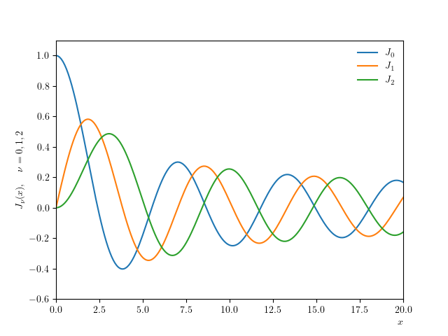
Figure 1: Example graph for the extended abstract.

5. CONCLUSIONS
Conclude your work incorporating important findings as well as future works (3-4 lines).

ACKNOWLEDGEMENTS
Please acknowledge your research grant, organization, scholarship (if relevant).

REFERENCES
References must be provided inside the full text as serial numbers within square brackets. They should be presented in the reference section in the serial order of appearance in Vancouver format as shown below.
[1] Winslow WM. Induced Fibration of Suspensions. Journal of Applied Physics 1949 Dec; 20:1137–40
[2] Rabinow J. The Magnetic Fluid Clutch. Transactions of the American Institute of Electrical Engineers 1948
Jan; 67:1308–15

